Complete the sections highlighted in yellow with your personal details and update the date. This document needs to be copied and pasted into the main body of your email. Remove the yellow highlighting, these instructions and email addresses prior to copying and pasting to your email.

THERE ARE 2 FILES TO ATTACH ALONG WITH THIS EMAIL.
- TGA freedom of information
- Mark Hobarts letter

Send to the email addresses below (these can be copied and pasted in one email). There is no need to sign the document. For Scott Morrison you will need to attach a copy of this letter on his contact page https://www.pm.gov.au/contact-your-pm

If Llew O’Brien is NOT your Federal Member, please delete his email and address details in the main body of the email, and add in the email and address for your Federal Member.

Subject: QR Code check-in App

To:
Senator.cash@aph.gov.au
Llew.obrien@aph.gov.au
Senator.canavan@aph.gov.au
Senator.chisholm@aph.gov.au
Senator.green@aph.gov.au
Senator.hanson@aph.gov.au
Senator.mcdonald@aph.gov.au
Senator.mcgrath@aph.gov.au
Senator.rennick@aph.gov.au
Senator.roberts@aph.gov.au
Senator.scarr@aph.gov.au
Senator.stoker@aph.gov.au
Senator.waters@aph.gov.au
Senator.watt@aph.gov.au

Scott Morrison (“you, your”), acting as
Prime Minster
Parliament House
Canberra
ACT
2600

and

Michaelia Cash (“you, your”), acting as
Attorney-General
PO Box 1966
West Perth
WA
6872
Email: Senator.cash@aph.gov.au

and

Llew O’Brien, (“you,your”),acting as
Member for Wide Bay, QLD
PO Box 283
Maryborough
QLD
4566
Email: llew.obrien@aph.gov.au

and

Matthew Canavan, (“you, your”), acting as
Senator for Queensland
PO Box 737
Rockhampton
QLD
4700
Email: Senator.canavan@aph.gov.au

and

Anthony Chisholm, (“you, your”), acting as
Senator for Queensland
PO Box 2246
Strathpine
QLD
4500
Email: Senator.chisholm@aph.gov.au

and

Nita Green, (“you, your”), acting as
Senator for Queensland
PO Box 4716
Cairns Post Shop
QLD
4870
Email: Sentator.green@aph.gov.au

and

Pauline Hanson, (“you, your”), acting as
Senator for Queensland
GPO Box 228
Brisbane
QLD
4001
Email: Senator.hanson@aph.gov.au

and

Susan McDonald, (“you, your”), acting as
Senator for Queensland
PO Box 2185
Townsville
QLD
4810
Email: Senator.mcdonald@aph.gov.au

and

James McGrath, (“you, your”), acting as
Senator for Queensland
PO Box 772
Nambour
QLD
4560
Email: Senator.mcgrath@aph.gov.au

and

Gerard Rennick, (“you, your”), acting as
Senator for Queensland
PO Box 2350
Chermside Centre
QLD
4032
Email: Senator.rennick@aph.gov.au

and

Malcolm Roberts, (“you, your”), acting as
Senator for Queensland
PO Box 228
Brisbane
QLD
4000
Email: Senator.roberts@aph.gov.au

and

Paul Scarr, (“you, your”), acting as
Senator for Queensland
PO Box 4287
Springfield Central
QLD
4300
Email: Senator.scarr@aph.gov.au

and

Amanda Stoker, (“you, your”), acting as
Senator for Queensland
GPO Box 228
Brisbane
QLD
4001
Email: Senator.stoker@aph.gov.au

and

Larissa Waters, (“you, your”), acting as
Senator for Queensland
Locked Bag 3004
Paddington
QLD
4064
Email: Senator.waters@aph.gov.au

and

Murray Watt, (“you, your”), acting as
Senator for Queensland
PO Box 310
Southport Business Centre
QLD
4215
Email: Senator.watt@aph.gov.au

Dear recipients named above herein,

I know it is my duty to keep you informed as to MY WILL on any matter that comes before the Parliament or should come before the Parliament.
It has come to my attention that our government entity and its subdivision, agents or assigns has mandated the use of QR Codes in Queensland cafes, restaurants, pubs and clubs from 1 May 2021. The Queensland government is forcing businesses to register for the QR Code check-in app and has indicated it plans to expand the QR Code App system and gradually include many other industries and venues over time. Some of those planned for gradual inclusion are libraries, banks, hairdressers, hardware shops, schools, cinemas, service stations, tourism attractions, government departments, public transport and entertainment venues.
The QR Codes affect businesses, employees within that business and others who trade with that business.
This mandate is unlawful and breaches a number of human rights and political liberties, not to mention federal and other legislation, including, but not limited to:
- Privacy Act 1988 (Section 94H) - it is illegal to enforce people to check in with a QR code or to refuse service to a person who doesn’t scan the QR code. The penalty for enforcing QR scanning or service can be a 5-year jail term or 300 penalty units.
- Charter of Human Rights and Responsibilities 2006 (Vic) –
  - Section 5 (gives access to ICCPR and any Constitutional law)
  - Section 8 (Recognition and equality before the law)
  - Section 12 (Freedom of movement)
  - Section 13 (Privacy and reputation)
  - Section 14 (Freedom of thought, conscience, religion and belief)
  - Section 15 (Freedom of expression)
  - to name a few.
- International Covenant of Civil and Political Rights –
  - Article 1
  - Article 2
  - Article 3
  - Article 5
  - Article 7
  - Article 8
  - Article 9
  - Article 16
  - Article 17
  - Article 18
  - Article 19
  - Article 20

- Fair Work Commission -

Section 94H of the Privacy Act 1988
- A person commits an offence if the person requires another person to:
  - download COVIDSafe to a communication device; or
  - have COVIDSafe in operation on a communication device; or
  - consent to uploading COVID app data from a communication device to the National COVIDSafe Data Store.
Penalty: Imprisonment for 5 years or 300 penalty units, or both.
- A person commits an offence if the person:
  - refuses to enter into, or continue, a contract or arrangement with another person (including a contract of employment); or
  - takes adverse action (within the meaning of the Fair Work Act 2009) against another person; or
  - refuses to allow another person to enter:
    - premises that are otherwise accessible to the public; or
    - premises that the other person has a right to enter; or
  - refuses to allow another person to participate in an activity; or
  - refuses to receive goods or services from another person, or insists on providing less monetary consideration for the goods or services; or
  - refuses to provide goods or services to another person, or insists on receiving more monetary consideration for the goods or services;
on the ground that, or on grounds that include the ground that, the other person:
  - has not downloaded COVIDSafe to a communication device; or
  - does not have COVIDSafe in operation on a communication device; or
  - has not consented to uploading COVID app data from a communication device to the National COVIDSafe Data Store.
Penalty: Imprisonment for 5 years or 300 penalty units, or both.
- To avoid doubt:
  - subsection (2) is a workplace law for the purposes of the Fair Work Act 2009; and
  - the benefit that the other person derives because of an obligation of the person under subsection (2) is a workplace right within the meaning of Part 3-1 of that Act.

What is the protection?
An employer must not take adverse action^{[1]} against an employee or prospective employee, on the grounds that they:
- have not downloaded COVIDSafe to a communication device
- do not have COVIDSafe in operation on a communication device, or
- have not consented to uploading COVID app data from a communication device to the National COVIDSafe Data Store.
As State and Federal laws can contradict each other, I state that the federal laws override and invalidate conflicting state laws and business directives, including the ones demanding the ‘COVIDSafe’ and other QR check-in apps (Section 109 of the Commonwealth Constitution).
In addition, the Check In Qld Privacy Policy states that this is a voluntary app. You do not have to use Check In Qld to check in at a venue or event.
https://www.covid19.qld.gov.au/check-in-qld/privacy
“This is a voluntary app. You do not have to use Check In Qld to check in at a venue or event - but if you don't, then you must register your attendance in that venue or event by other means. Please confirm the details of these alternative methods with the business or organisation”
The data collected is stored by the Queensland government. However, the current privacy statement on the app is in fact misleading and deceptive, this breaches section 12 DA, the ASIC act 2001 which may incur 10,000 penalty unit fines and Section 12 CA of the same ACT may incur a further 10,000 penalty unit fines.
“If required, CHDE ( Department of Communities, Housing and Digital Economy ) ABN 81 919 425 843 will disclose your personal information to Queensland Health who will use your information for the purposes of contact tracing. Information collected using the Check in Qld app may be disclosed to, and used:
- by authorities with powers and responsiblities in relation to COVID-19 (and those helping them) such as the Chief Health Officer and Queensland Health (including the Hospital and Health Services) for compliance acitivites, and for the purposes of overseeing and managing the Queensland Government’s COVID-19 response;
- where the use or disclosure is authorised or required by law. “

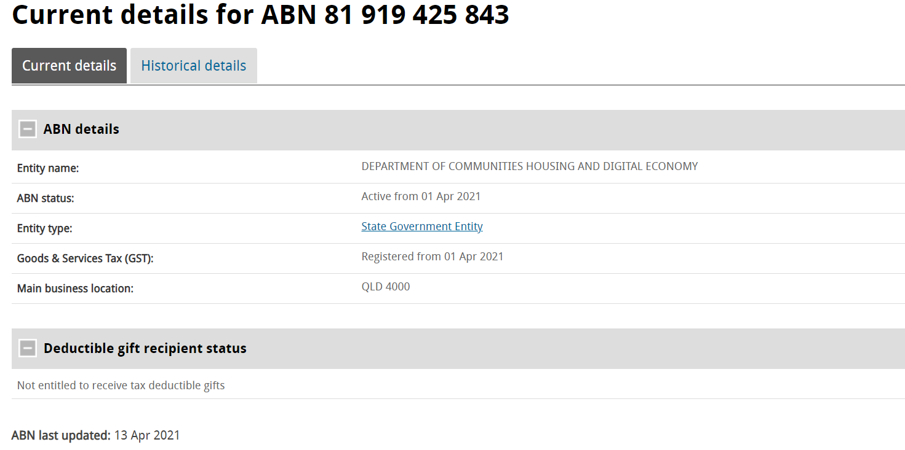
Every police officer in Queensland is an emergency officer under the Public Health Act and this would allow for information to be disclosed to the police for the extremely broad purpose of ‘compliance activities’ relating to Covid. The app’s privacy statement shows that the data may be used more broadly than just contact tracing. This would permit police access to the data for non-Covid related purposes. Again, this is encroaching on people’s privacy and rights.
In addition, security of information is never guaranteed:
- According to the Deputy Premier, Stephen Miles, making this app mandatory for pubs, clubs and restaurants will ‘allow for greater consistency, better access of data, and a more convenient user experience’. I observe that the Deputy Premier’s comments are all about data and not about the people’s rights, for which the government is tasked to protect.
- The Queensland Council for Civil Liberties (QCCL) President Michael Cope said in a media release on 1 April 2021, and I quote:
‘The QCCL is extremely concerned about the government’s decision to make the Checkin Qld app mandatory for entry to restaurants, pubs etc without adequate privacy protection. The QCCL calls on the government to provide assurances to the people of Queensland, that data collected from the app will be used solely for the stated purpose of contact tracing. QCCL also seeks assurances that information collected from the Check-in app will not be used for law enforcement purposes or any other additiional purpose. Those assurances can only be satisfactorily provided by the passage of specific legislation limiting the use of data collected and providing for its destruction.’
https://www.qccl.org.au/newsblog/mandatory-checkin-app-raises-privacy-issues
- QR Codes can be manipulated by a threat actor who can easily paste their malicious QR code on top of a real one and create their own copies, and based on appearance, it is not possible to tell if the contents are safe or malicious.
Queensland hospitality businesses who fail with the new public health direction, will be hit with harsh penalties, including fines of $13,345 or six months imprisonment. Some critics have warned the Queensland Government is using inflated health fears as a trojan horse in order to usher in a full spectrum tracking and surveillance apparatus that will become a permanent fixture in our lives for the foreseeable future.
Queensland Council for Civil Liberties (QCCL) president Michael Cope has said he is "extremely concerned" about the new mandatory program, which has no privacy safeguards and no ‘end date’ for once the public health ‘emergency’ is over. Once that happens, the QR Code App will be able to log in, capture, monitor and surveil all Queenslanders’ movement, associations and behaviour on a mass scale. Because the app is tied to your identification, it will govern where you can go, using QR code scanners and digital check-ins. It will be used to track your movements, your contacts, and eventually, will display the results of any recent Covid-19 tests or vaccines you have had – or not had, as the case may be.
This makes the QR Code App a massive threat to many of our core rights, not least of which include our right to freedom of movement, freedom of association, right to bodily autonomy and right to privacy. Please refer to section 10 The Charter Of Human Rights VIC 2006 and ICCPR section 9, 16, 17, 18 and 19.
You, as a member of Parliament, must fulfill your democratically defined function and duty and refuse to bend to any party pressures and oppose this bill immediately.
The STATE OF QLD INC has no mandate from the last state election to minimize and remove Queenslander’s Human Rights in light of the attached FOIR which states that the TGA cannot provide a proof of COVID -19 virus isolation or existence. Please also see a letter from Dr Mark Hobart to Professor Brett Sutton.

It is MY WILL that NO QR Codes and Similar Apps be mandated upon any living Man or Living Woman. I DO NOT CONSENT TO THE USE OF QR CODE MANDATES IN CONTRAVENTION OF SECTION 94H, THE PRIVACY ACT 1988!!!
Constitution without the consent and express will of the Australian People by referendum is Tyranny.

PRINT NAME ............................................................
ADDRESS ................................................................
................................................................
..................................................STATE .....................
POSTCODE ...................... DATE ................

